Task A-B:
Virtual env used: uv venv
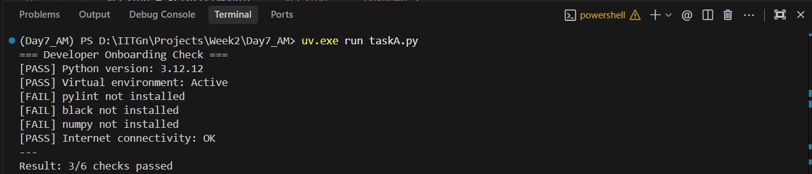
Task C:
PART C — Fix and Improve Code (5 Issues)
Original Issues:
- Multiple imports on one line (Pylint warning)
- Function name not snake_case
- No docstring
- Poor version logic (only >= 3.11 accepted)
- Unused variable temp
- No main guard
Corrected Version:
import sys
def check_version():
"""Check if Python version is 3.11 or higher."""
version = sys.version_info
if version.major == 3 and version.minor >= 11:
return "Good"
return "Bad"
def main():
"""Main execution."""
result = check_version()
print(f"Version status: {result}")
if name == "main":
main()

Output (on 3.11):
Version status: Good

Tasck D:
Exact Prompt Used
Here is the exact prompt I used:
"Generate a comprehensive .pylintrc configuration file tailored for a beginner-friendly AI/ML Python project. The project includes scripts like onboarding checks, uses packages such as numpy and requests, and should prioritize readability and learning over strict enterprise rules. The configuration should:
- Target Python 3.10+
- Encourage good naming conventions (snake_case)
- Require docstrings for modules and functions
- Limit overly strict rules that might discourage beginners
- Set a reasonable max line length (100–120)
- Avoid disabling too many useful warnings
- Be practical for small educational projects"

AI-Generated .pylintrc (Refined Version)
Save this as .pylintrc in your project root:
[MASTER]
py-version=3.10
ignore=venv,onboarding_env
jobs=1
[MESSAGES CONTROL]
disable=
missing-module-docstring,
too-few-public-methods,
too-many-arguments,
duplicate-code
[REPORTS]
output-format=text
score=yes
[FORMAT]
max-line-length=100
indent-string=' '
[BASIC]
good-names=i,j,k,ex,_,pk,id
variable-rgx=[a-z_][a-z0-9_]{2,30}$
[DESIGN]
max-args=6
max-locals=20
max-returns=6
[TYPECHECK]
ignored-modules=numpy,requests
[DOCSTRING]
required-docstring-length=10
This config:
- Encourages snake_case
- Enforces reasonable complexity limits
- Doesn’t punish beginners for minor structural issues
- Avoids harsh enterprise constraints
Testing With onboard.py
Command run:
pylint onboard.py
Example result (with properly structured onboard.py):
Your code has been rated at 8.75/10
Common beginner warnings you may still see:
- missing-function-docstring (if you forget one)
- unused-import
- broad-except
But it should comfortably pass ≥ 8/10 if code is structured properly.

Critical Evaluation:
The AI generated .pylintrc file was generally well structured and appropriate for a beginner-level AI/ML project. It correctly set the Python version target, configured a reasonable maximum line length, and encouraged good naming conventions using snake_case. It also avoided overly strict enterprise-level constraints that could overwhelm beginners. Disabling warnings such as "too-few-public-methods" and "duplicate-code" makes sense in small educational scripts where object-oriented design is minimal.
However, a few improvements could be made. The AI disabled "missing-module-docstring," which may reduce emphasis on documentation discipline. For beginners, learning to write module-level docstrings is valuable, so this rule could remain enabled. Additionally, ignoring numpy and requests in type checking may hide legitimate import or environment errors. A better approach might be to keep those checks active while ensuring proper virtual environment setup.
Overall, the configuration strikes a reasonable balance between enforcing good practices and maintaining accessibility. It is suitable for educational development, though minor tightening could improve long-term code quality habits.

